BOWIE MIDDLE SCHOOL DRESS CODE

2025-2026

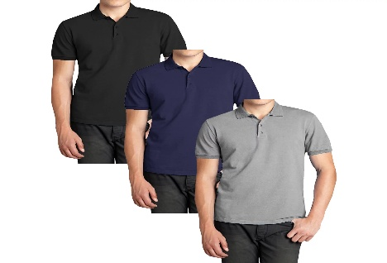

[This Photo](http://www.frugal-freebies.com/2023/11/comfortable-and-stylish.html) by Unknown Author is licensed under [CC BY-NC-ND](https://creativecommons.org/licenses/by-nc-nd/3.0/)

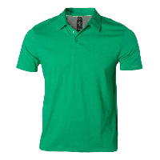

*Tops: Polos can be Green, White, Navy Blue and Light Blue, Black, Grey (Spirit Shirt can be worn all week with uniform pants or Jeans - Friday’s only)

*Bottoms: Uniform Style Khaki, Navy Blue or Black (no rips or tears) must have pockets, button and zipper. (Shorts and Skirts must be no more than 2 inches above the knee)

*Fridays: Students can wear Jeans (no rips or tears above the knee) with Spirit Shirts or Polo

*Sweaters: Bowie Hoodie or Solid Color Sweaters with NO logos (school colors only)

*Shoes: Sneakers, Crocs w/backstrap, NO Slides (Students must wear sneakers during PE)